**Practice queue-template creation using Web GUI and Solace CLI with different configurations**

* **Template creation using web GUI:**

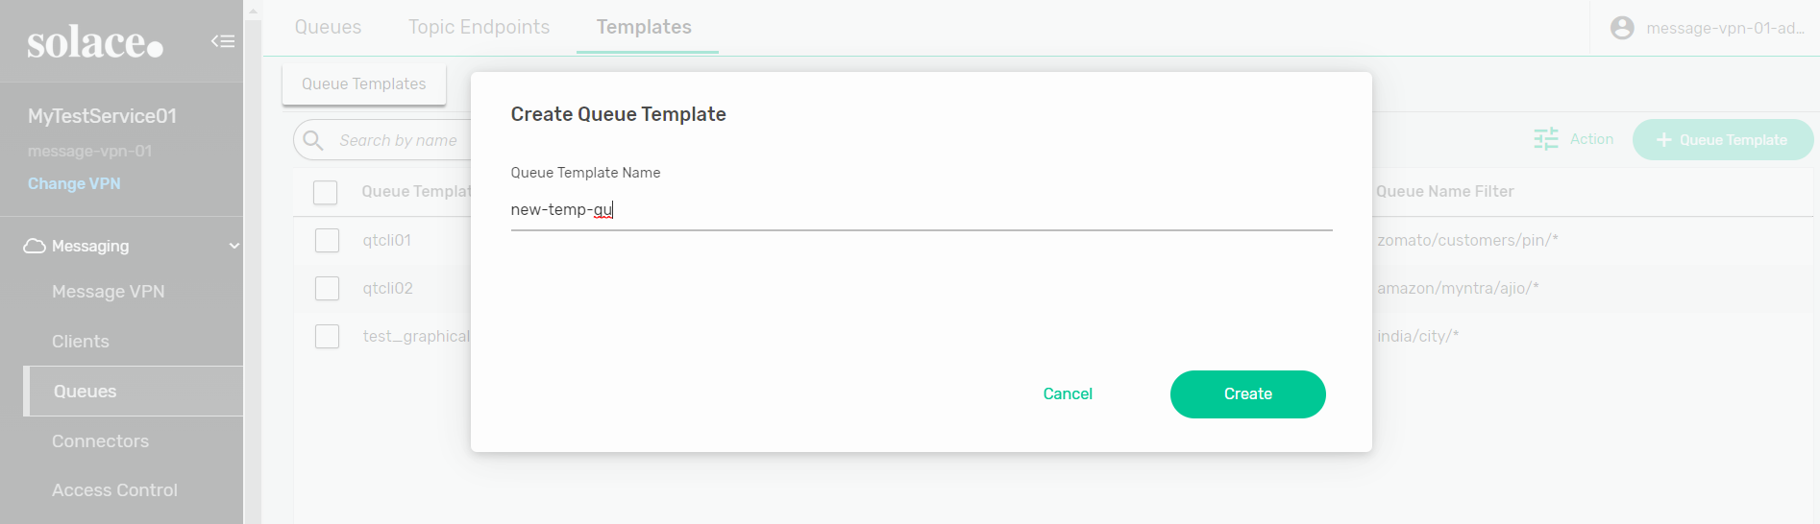

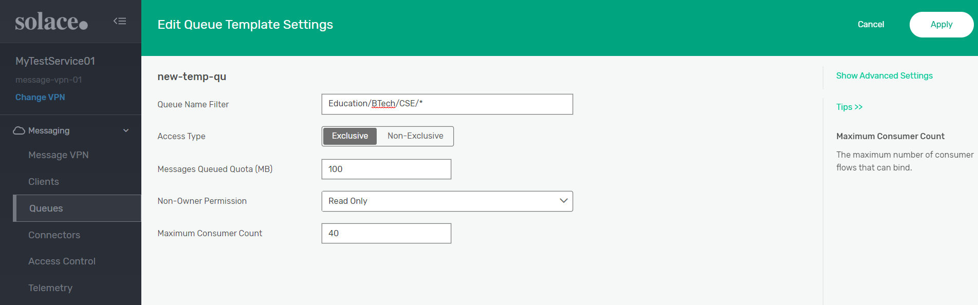

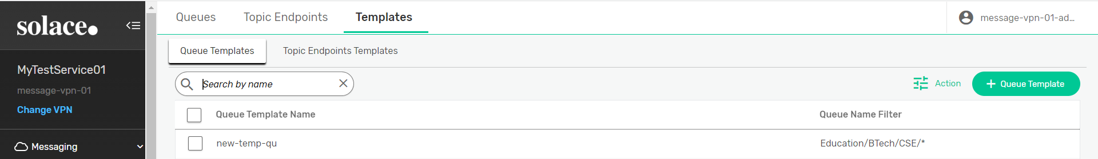

**Using CLI:**

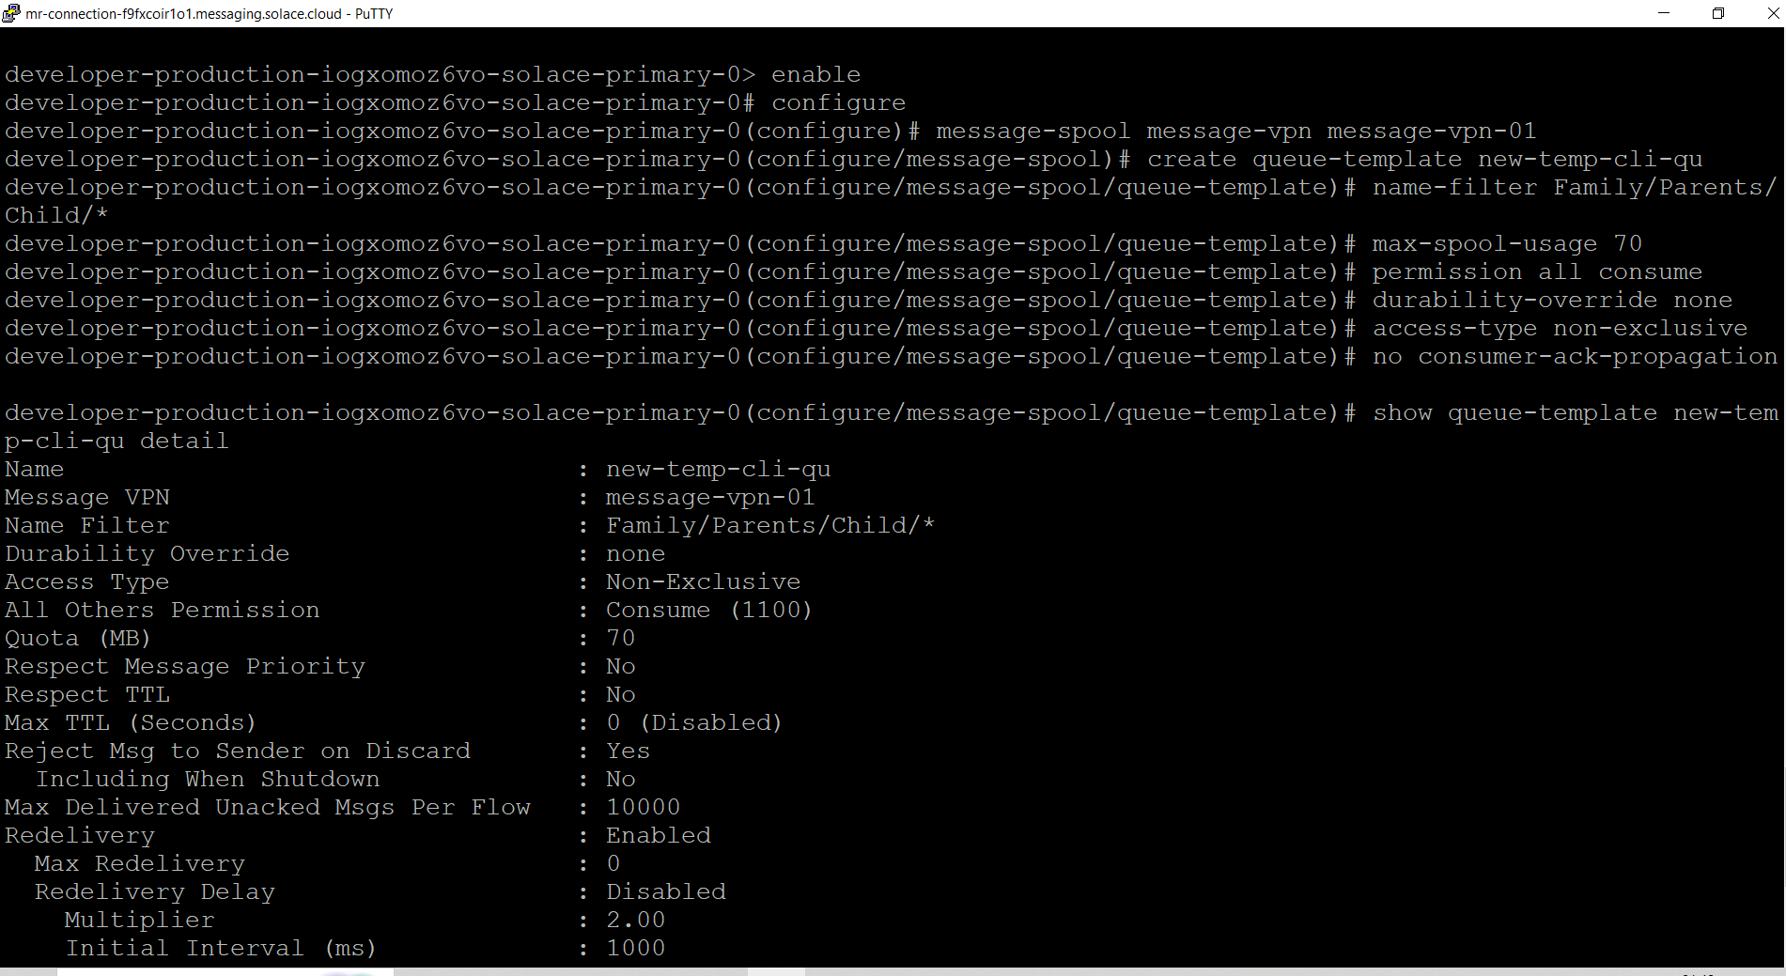

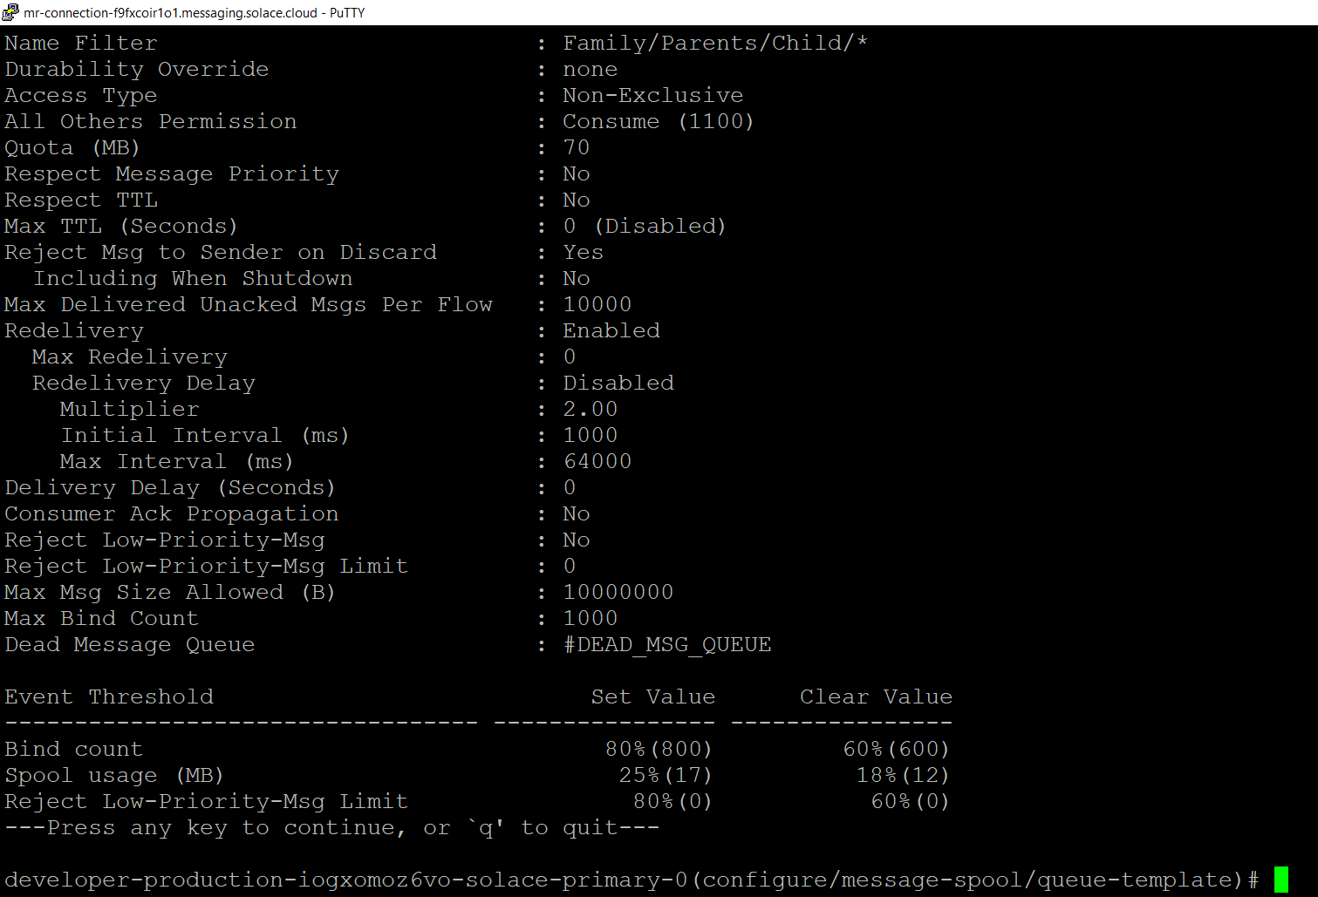

**Show new Queue in Solace Console:**

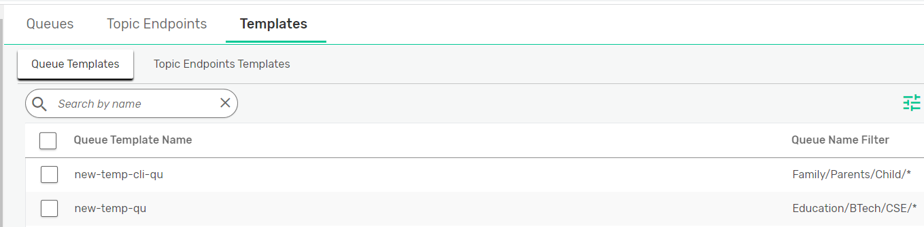

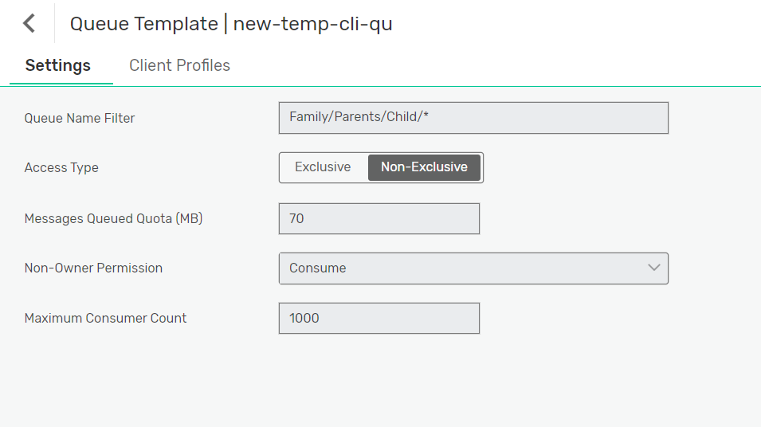

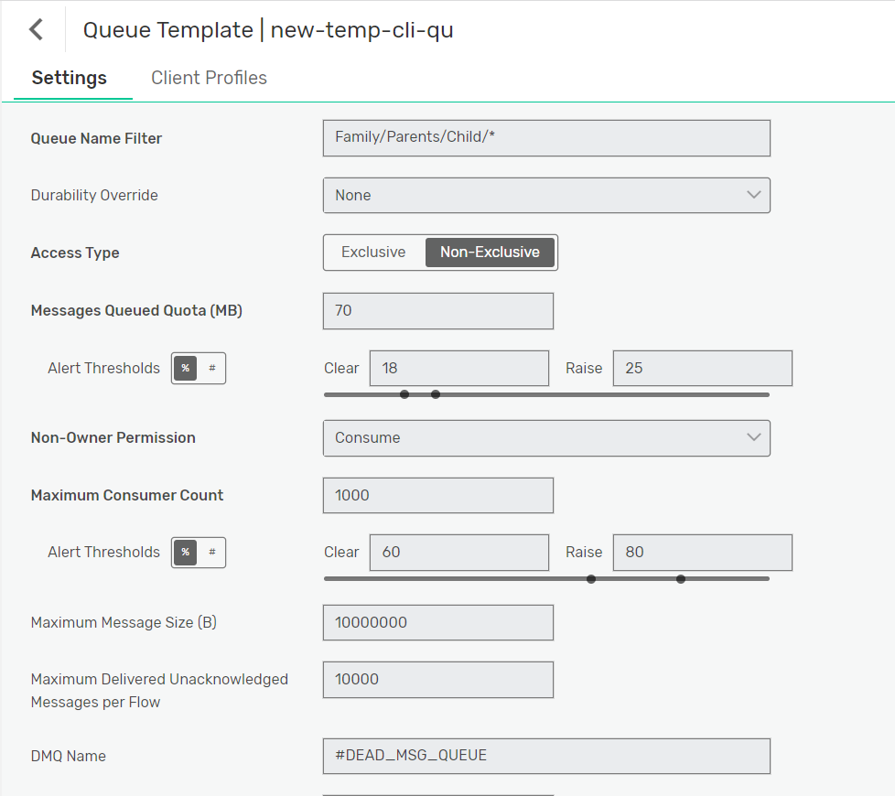

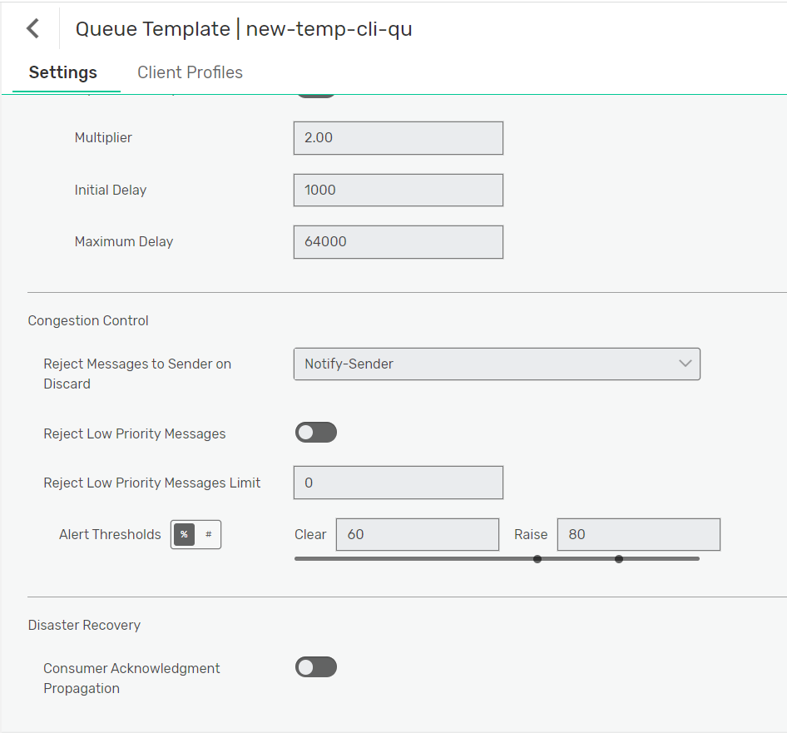

**4. Read about "Event Streaming" || How event streaming works in EDA**

Event Streaming refers to the practice of capturing, transmitting, and processing events in real-time within an Event-Driven Architecture (EDA). "events" are significant occurrences or state changes in a system, and "event streaming" involves the continuous flow of these events from sources to consumers, enabling real-time communication, data processing, and decision-making.

Here's how event streaming works within an Event-Driven Architecture:

* **Event Generation**
* **Event Producer**
* **Event Streaming Platform**
* **Publish-Subscribe (Pub-Sub) Model**
* **Event Distribution**
* **Event Consumers**
* **Event Processing**
* **Scalability and Resilience**
* **Event Retention**
* **Event-Driven Microservices**